## Accessing Integrated Mapping

In [The Canvas](/docs/rapid-plan/4.%20The%20Canvas/) we covered how to start a new plan from different plan types, so in this section we will focus on aspects only relevant to integrated mapping.

**To access the integrated mapping feature:**

* Select the **New Plan Wizard** on the Welcome screen.
* In **step 1** select a **Base Map** plan.
* In **step 2** you can specify a plan scale or leave it as the default scale.
* Now specify a job location. You can search location by street address or longitudinal and latitudinal coordinates.
* The red cross in the center of the map points to the job location, scroll the map as necessary to the desired location.
* Once the scale and location are set, select **Create Plan** at the top.
* 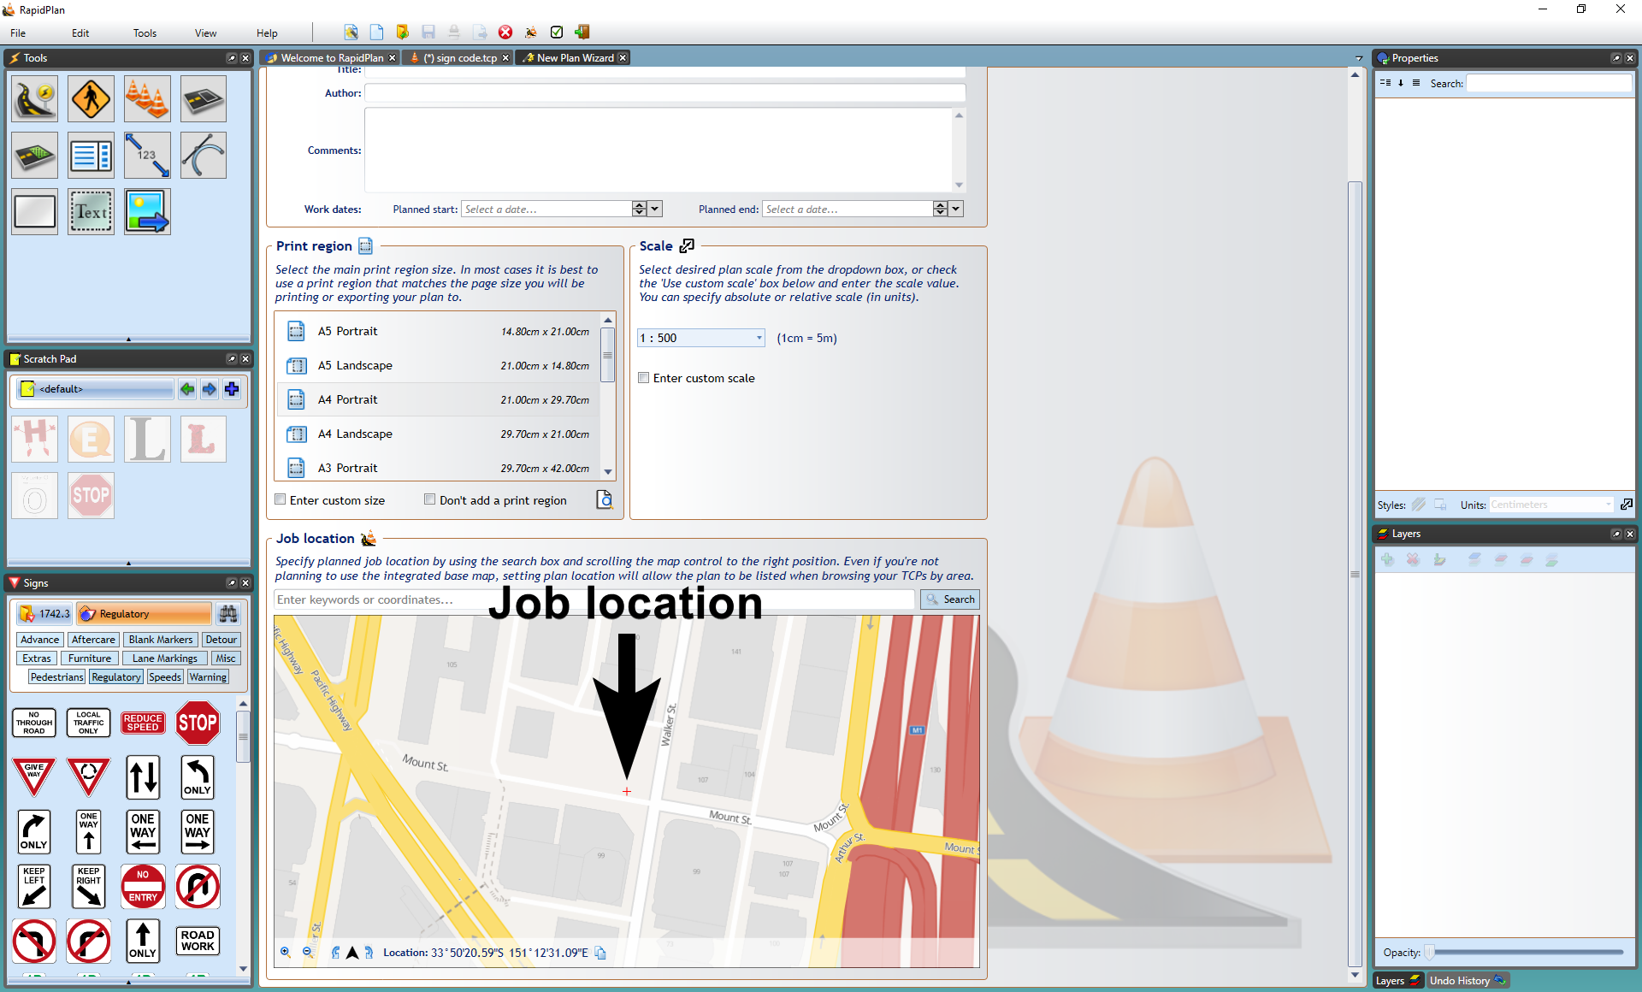
* Searching_for_Job_Location
* **Note:** As it is an unrestricted canvas, you can scroll and zoom to anywhere on the map you like. This means it can be important to be fairly precise when setting your job location in **step 2** so that you can find the exact spot when searching plans by location in the future.
* 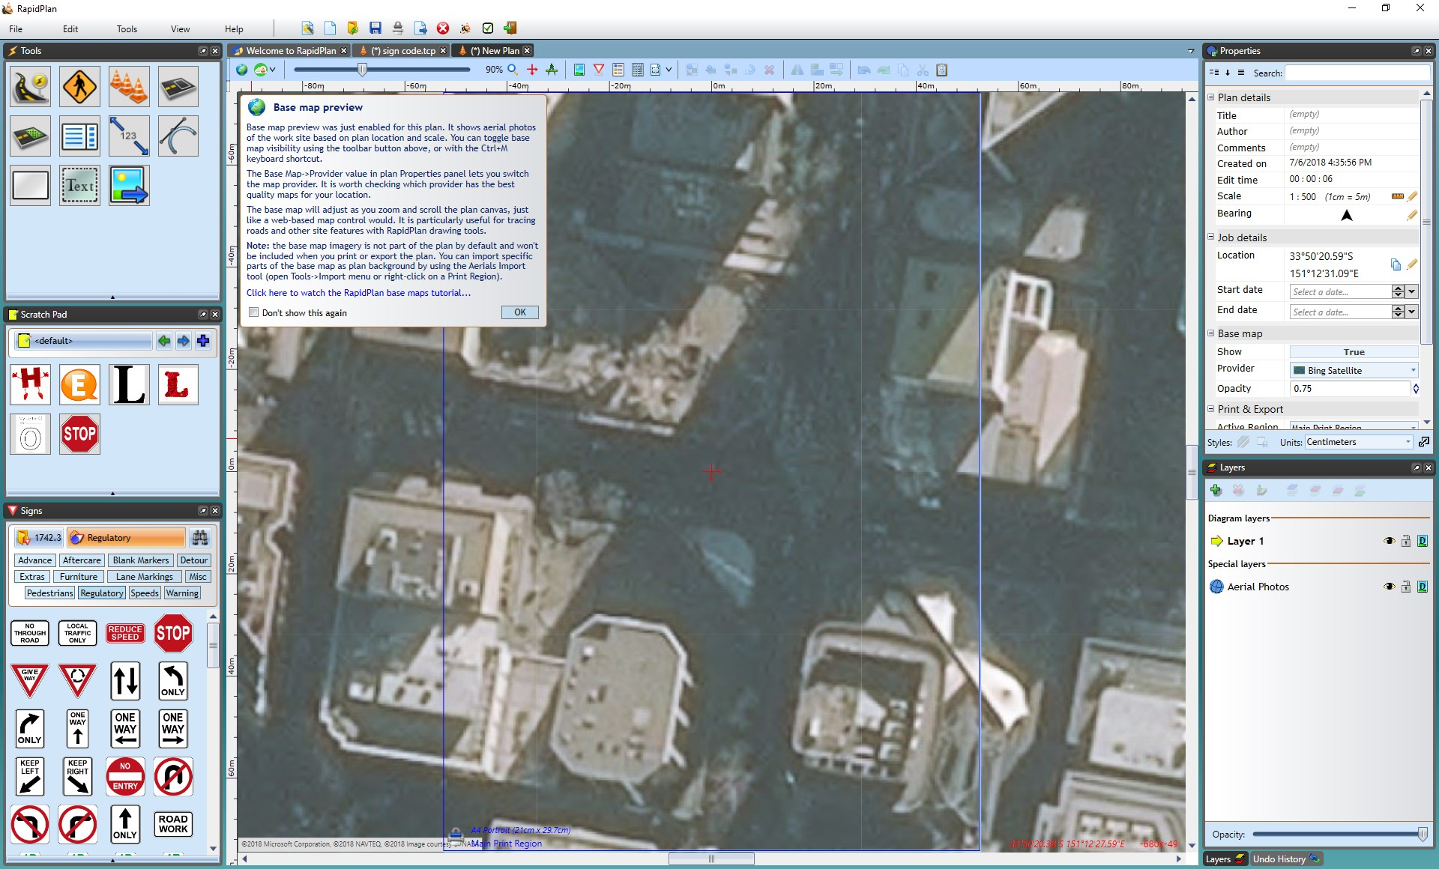
* New_Base_Map_Plan